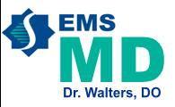 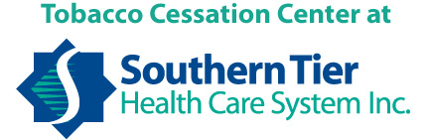

**I want to congratulate and extend online privileges until 06/30/2016 to the following 2 members of Cattaraugus County Sheriff’s Office SRT who have successfully completed their annual WREMAC Skills Evaluations and have submitted the proper paperwork to STEMS:**

Ellis, Anthony - #238385, EMT-CC

Kuhn, Robert - #342527, EMT-B

**Any active member of your agency who is not listed must complete their annual skills and send in to STEMS by August 1, 2015, to remain online as an active provider.** Hard copies of the evaluation sheets, PPAs, and Ancillary Cards should be kept for review if requested. This information needs to be accessible for review either by myself or my designee.

Thanks again for all you do!



Dr. B. Walters

CC: STEMS